**Problem 1**

**Aim:**

Maximum Depth of Binary Tree

**Code:**

class Solution {

public int maxDepth(TreeNode root) {

if (root == null) {

return 0;

}

int leftDepth = maxDepth(root.left);

int rightDepth = maxDepth(root.right);

return Math.max(leftDepth, rightDepth) + 1;

}

}

**Output:**

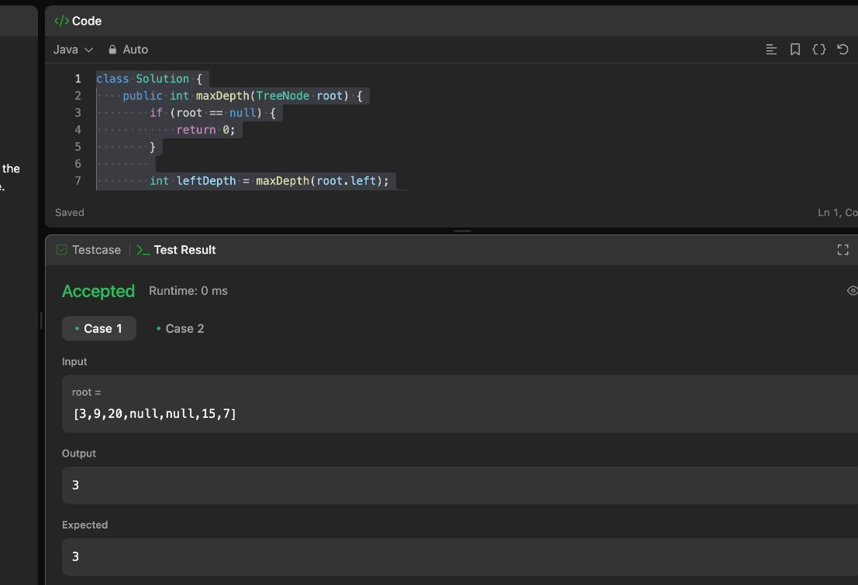

**Problem 2**

**Aim:**

Validate Binary Search Tree

**Code:**

class Solution {

public boolean isValidBST(TreeNode root) {

return isValidBST(root, Long.MIN_VALUE, Long.MAX_VALUE);

}

private boolean isValidBST(TreeNode node, long min, long max) {

if (node == null) {

return true;

}

if (node.val <= min || node.val >= max) {

return false;

}

return isValidBST(node.left, min, node.val) && isValidBST(node.right, node.val, max);

}

}

**Output:**

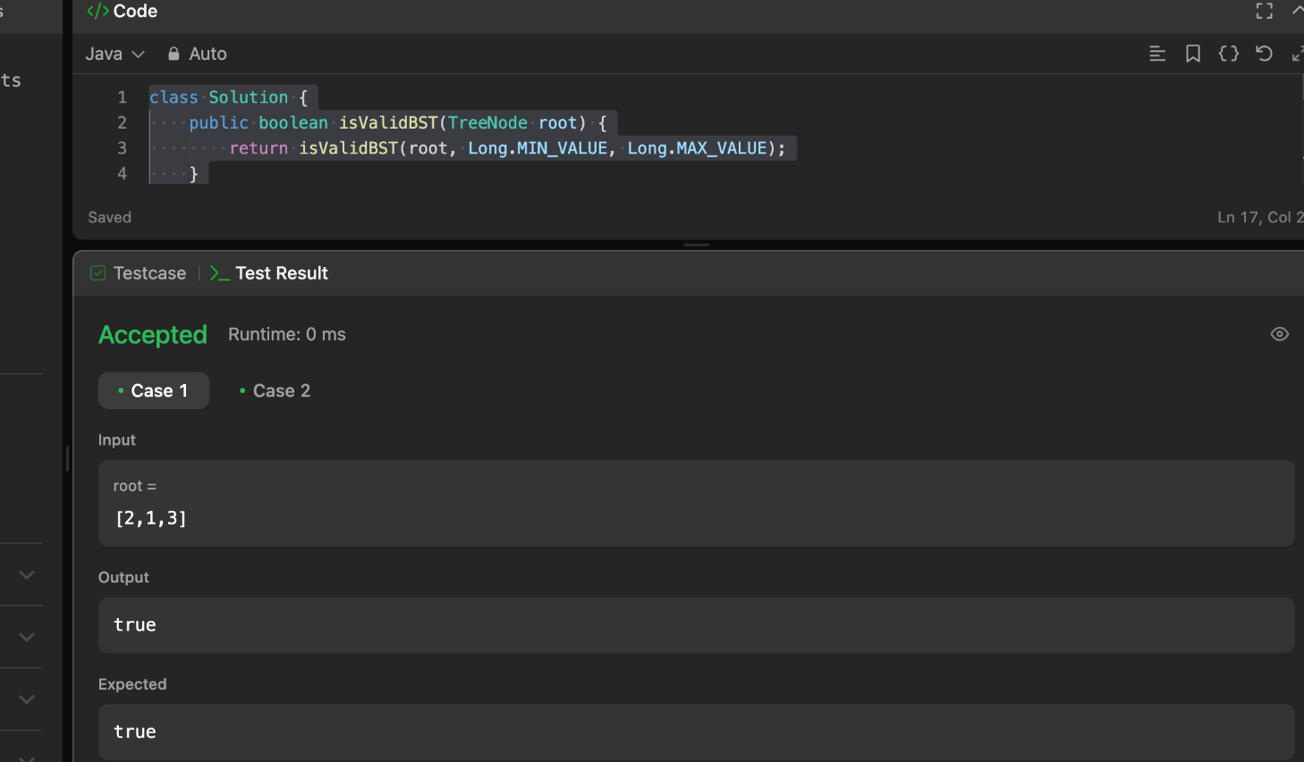

**Problem 3**

**Aim:** **Symmetric Tree**

**Code : class Solution {**

**public boolean isSymmetric(TreeNode root) {**

**if (root == null) {**

**return true;**

**}**

**return isMirror(root.left, root.right);**

**}**

**private boolean isMirror(TreeNode t1, TreeNode t2) {**

**if (t1 == null && t2 == null) {**

**return true;**

**}**

**if (t1 == null || t2 == null) {**

**return false;**

**}**

**return (t1.val == t2.val)**

**&& isMirror(t1.left, t2.right)**

**&& isMirror(t1.right, t2.left);**

**}**

**}**

**Output:**

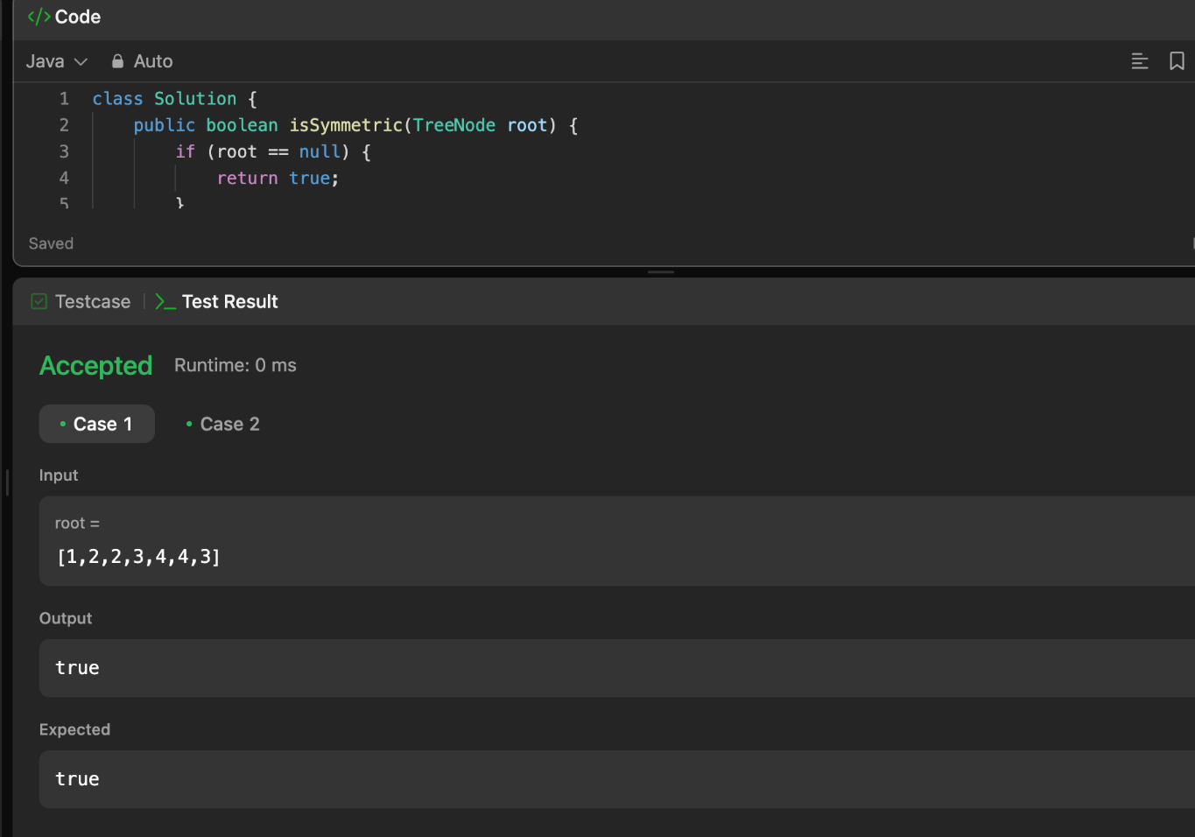

**Problem 4**

**Aim: Binary Tree Level Order Traversal**

**Code:**

import java.util.*;

class Solution {

public List<List<Integer>> levelOrder(TreeNode root) {

List<List<Integer>> result = new ArrayList<>();

if (root == null) {

return result;

}

Queue<TreeNode> queue = new LinkedList<>();

queue.offer(root);

while (!queue.isEmpty()) {

int levelSize = queue.size();

List<Integer> currentLevel = new ArrayList<>();

for (int i = 0; i < levelSize; i++) {

TreeNode currentNode = queue.poll();

currentLevel.add(currentNode.val);

if (currentNode.left != null) {

queue.offer(currentNode.left);

}

if (currentNode.right != null) {

queue.offer(currentNode.right);

}

}

result.add(currentLevel);

}

return result;

}

}

**Output:**

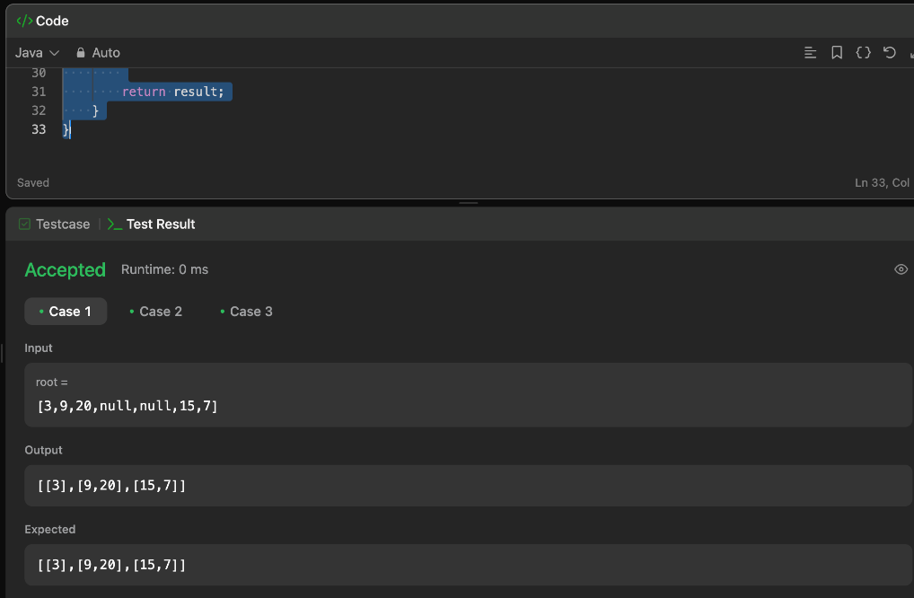

**Problem 5**

**Aim:**

**Convert Sorted Array to Binary Search Tree**

**Code:**

class Solution {

public TreeNode sortedArrayToBST(int[] nums) {

if (nums == null || nums.length == 0) {

return null;

}

return helper(nums, 0, nums.length - 1);

}

private TreeNode helper(int[] nums, int left, int right) {

if (left > right) {

return null;

}

int mid = left + (right - left) / 2;

TreeNode root = new TreeNode(nums[mid]);

root.left = helper(nums, left, mid - 1);

root.right = helper(nums, mid + 1, right);

return root;

}

}

**Output:**

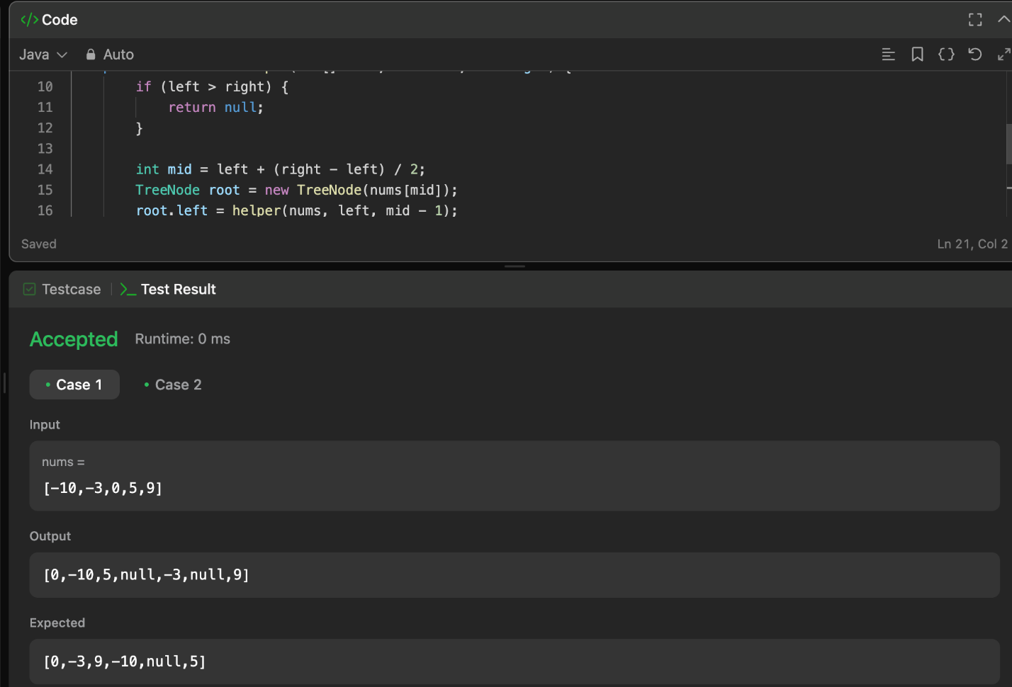

**Problem 6**

**Aim:**

**Binary Tree Inorder Traversal**

**Code:**

import java.util.*;

class Solution {

public List<Integer> inorderTraversal(TreeNode root) {

List<Integer> result = new ArrayList<>();

Stack<TreeNode> stack = new Stack<>();

TreeNode current = root;

while (current != null || !stack.isEmpty()) {

while (current != null) {

stack.push(current);

current = current.left;

}

current = stack.pop();

result.add(current.val);

current = current.right;

}

return result;

}

}

**Output:**

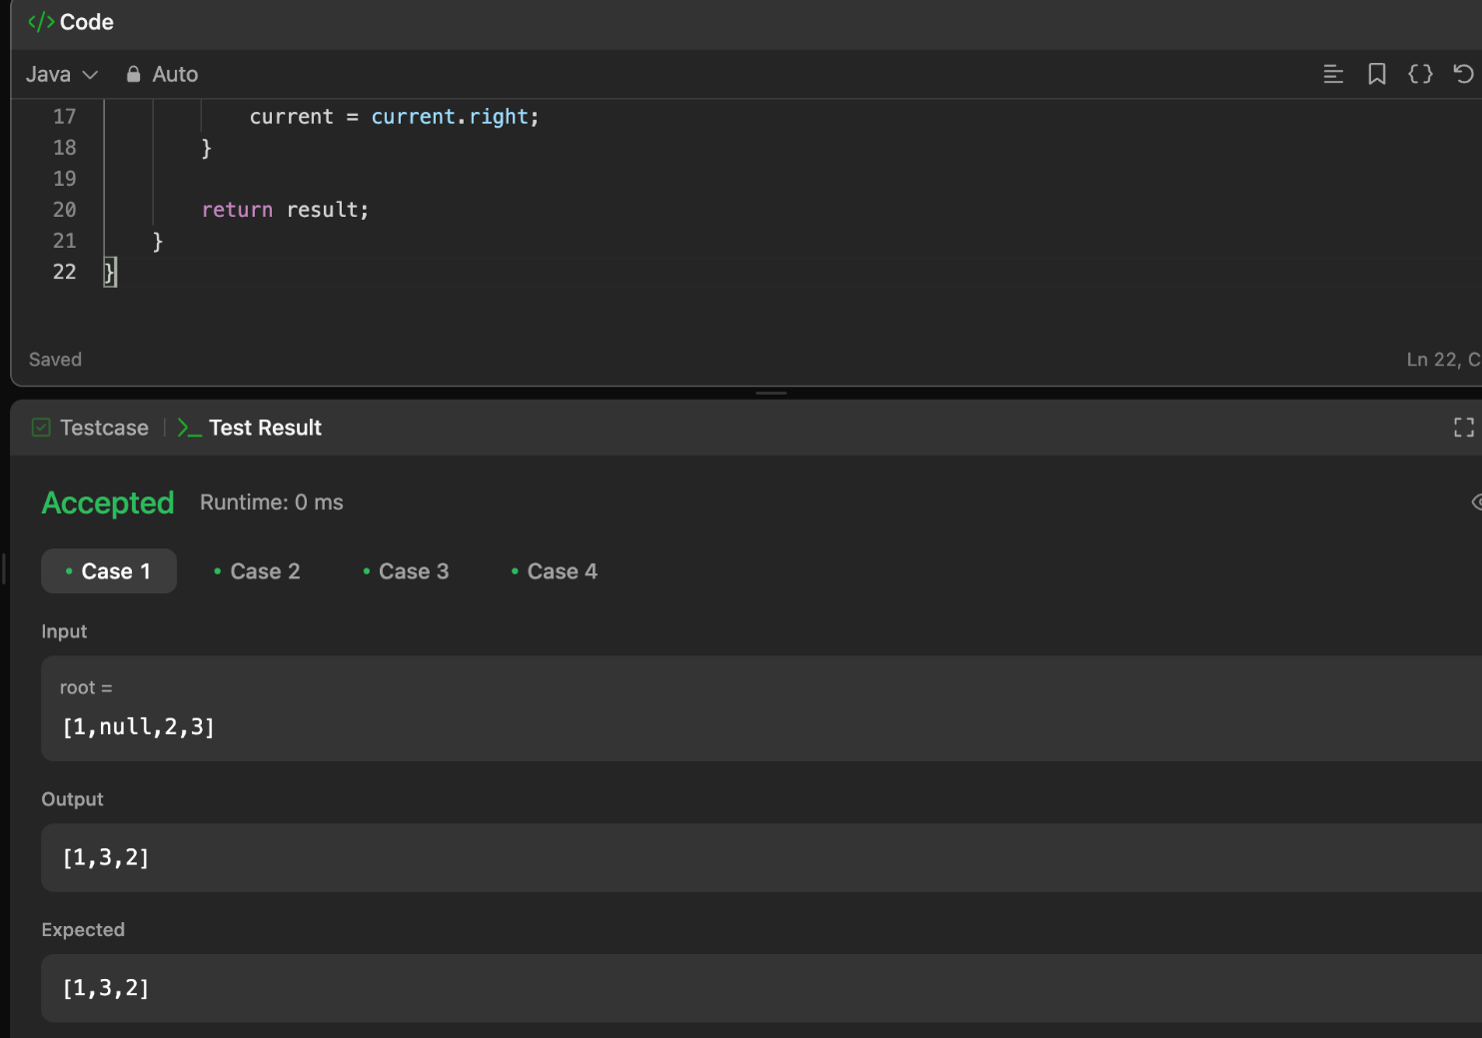

**Problem 7**

**Aim:**

**Construct Binary Tree from Inorder and Postorder Traversal**

**Code:**

import java.util.*;

class Solution {

public TreeNode buildTree(int[] inorder, int[] postorder) {

if (inorder == null || postorder == null || inorder.length != postorder.length) {

return null;

}

Map<Integer, Integer> inorderMap = new HashMap<>();

for (int i = 0; i < inorder.length; i++) {

inorderMap.put(inorder[i], i);

}

return buildTreeHelper(inorder, 0, inorder.length - 1, postorder, 0, postorder.length - 1, inorderMap);

}

private TreeNode buildTreeHelper(int[] inorder, int inStart, int inEnd, int[] postorder, int postStart, int postEnd, Map<Integer, Integer> inorderMap) {

if (inStart > inEnd || postStart > postEnd) {

return null;

}

int rootVal = postorder[postEnd];

TreeNode root = new TreeNode(rootVal);

int rootIndex = inorderMap.get(rootVal);

int leftSize = rootIndex - inStart;

root.left = buildTreeHelper(inorder, inStart, rootIndex - 1, postorder, postStart, postStart + leftSize - 1, inorderMap);

root.right = buildTreeHelper(inorder, rootIndex + 1, inEnd, postorder, postStart + leftSize, postEnd - 1, inorderMap);

return root;

}

}

**Output:**

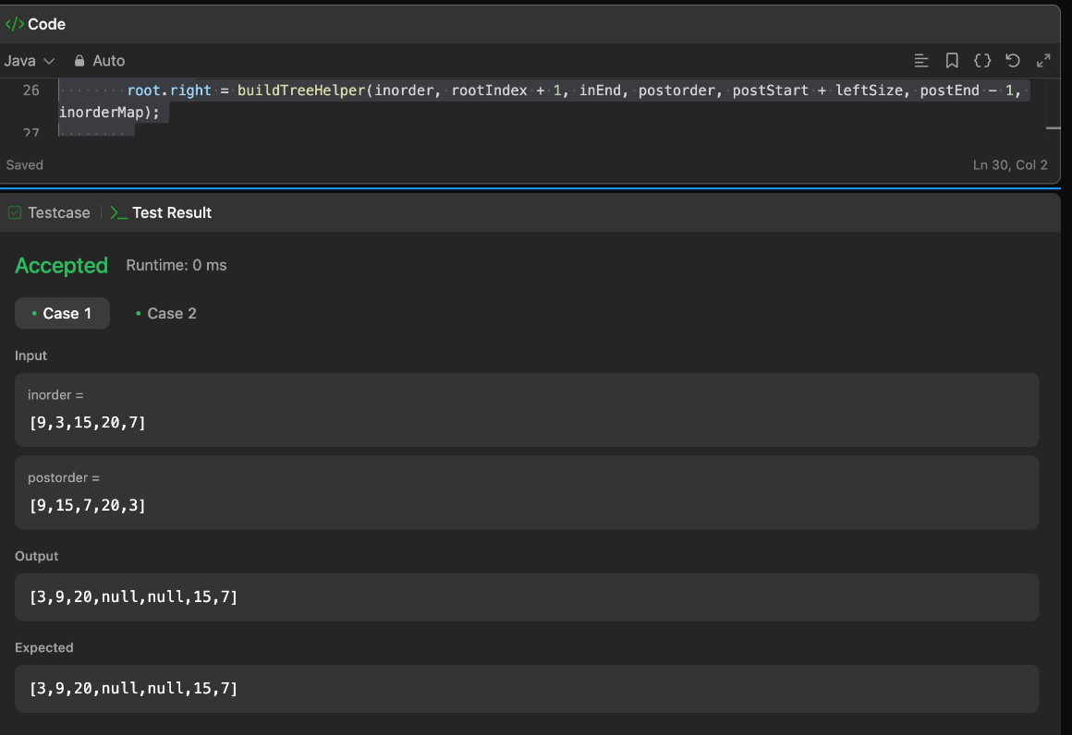

**Problem 8**

**Aim:**

**Kth Smallest element in a BST**

**Code:**

**import java.util.*;**

**class Solution {**

**public TreeNode buildTree(int[] inorder, int[] postorder) {**

**if (inorder == null || postorder == null || inorder.length != postorder.length) {**

**return null;**

**}**

**Map<Integer, Integer> inorderMap = new HashMap<>();**

**for (int i = 0; i < inorder.length; i++) {**

**inorderMap.put(inorder[i], i);**

**}**

**return buildTreeHelper(inorder, 0, inorder.length - 1, postorder, 0, postorder.length - 1, inorderMap);**

**}**

**private TreeNode buildTreeHelper(int[] inorder, int inStart, int inEnd, int[] postorder, int postStart, int postEnd, Map<Integer, Integer> inorderMap) {**

**if (inStart > inEnd || postStart > postEnd) {**

**return null;**

**}**

**int rootVal = postorder[postEnd];**

**TreeNode root = new TreeNode(rootVal);**

**int rootIndex = inorderMap.get(rootVal);**

**int leftSize = rootIndex - inStart;**

**root.left = buildTreeHelper(inorder, inStart, rootIndex - 1, postorder, postStart, postStart + leftSize - 1, inorderMap);**

**root.right = buildTreeHelper(inorder, rootIndex + 1, inEnd, postorder, postStart + leftSize, postEnd - 1, inorderMap);**

**return root;**

**}**

**public int kthSmallest(TreeNode root, int k) {**

**Stack<TreeNode> stack = new Stack<>();**

**TreeNode current = root;**

**int count = 0;**

**while (current != null || !stack.isEmpty()) {**

**while (current != null) {**

**stack.push(current);**

**current = current.left;**

**}**

**current = stack.pop();**

**count++;**

**if (count == k) {**

**return current.val;**

**}**

**current = current.right;**

**}**

**return -1; // Should not reach here if k is valid**

**}**

**}**

**Output:**

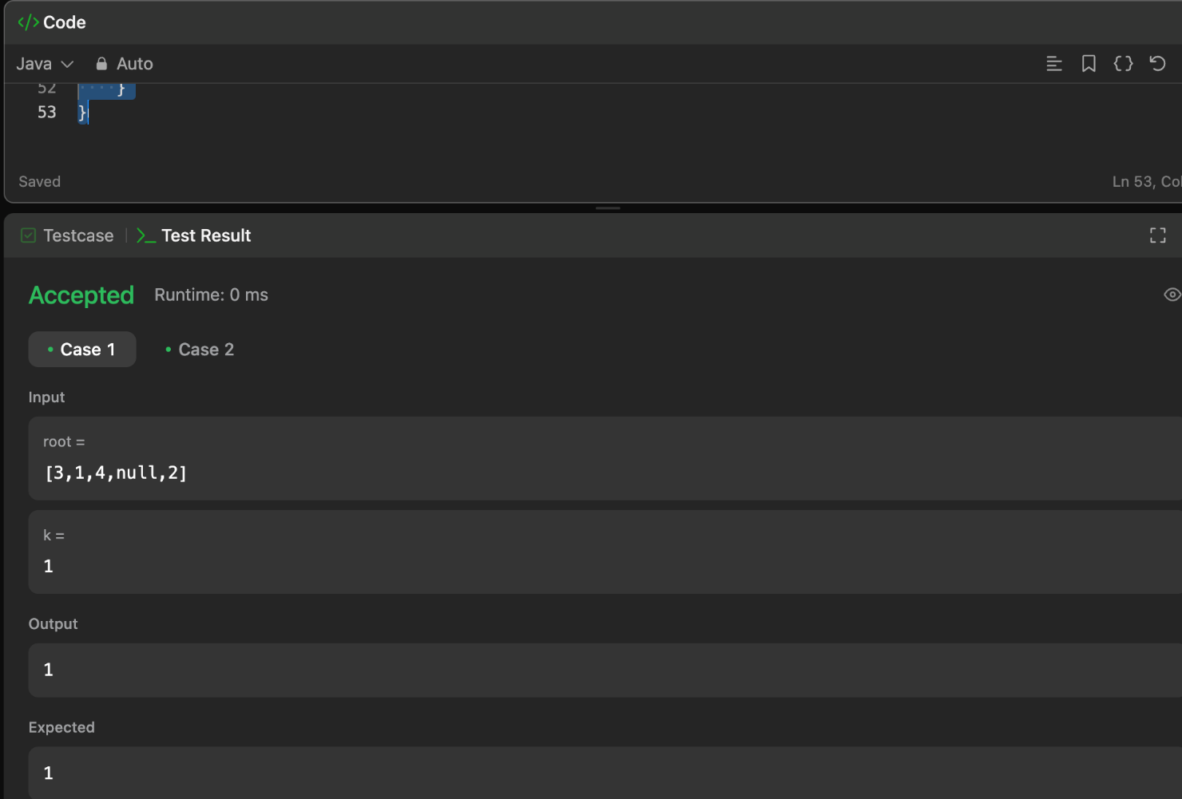

**Problem 9**

**Aim:**

Populating Next Right Pointers in Each Node

**Code:**

class Solution {

public Node connect(Node root) {

if (root == null) {

return null;

}

Node leftmost = root;

while (leftmost.left != null) {

Node current = leftmost;

while (current != null) {

// Connect left child to right child

current.left.next = current.right;

// Connect right child to the left child of next node

if (current.next != null) {

current.right.next = current.next.left;

}

// Move to the next node in the current level

current = current.next;

}

// Move to the next level

leftmost = leftmost.left;

}

return root;

}

}

**Output:**

